Graphics Project – COSC3000 2024 S1

*By Joy Yin – s4740051*

**Displaying 3D Objects:**

* Python was used to display the objects and perform transformations.
* Added a flag object that will not be transformed from the starting position as a ***reference point*** to demonstrate the transformations performed on other objects.
* The ‘ground’ in this world is represented with the grid.

Beginning Position:

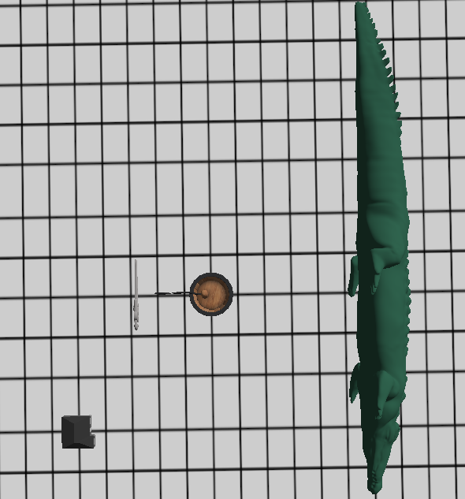

Figure 1: Beginning position Bird’s EyeView

Rotating Crocodile:

* The first attempt used the make_rotation_x() function but this rotated the crocodile around the origin point (flag), which meant that it did not rotate in its place.
* As such, a new transformation function was created to rotate the object around a specified point

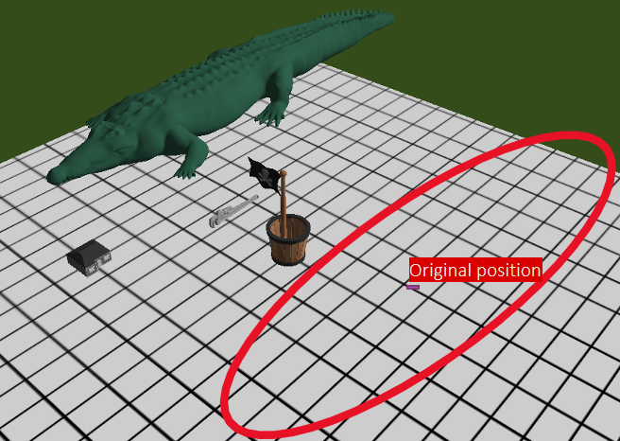

**APPENDIX:**

APPENDIX 1:

APPENDIX 2: